Names:_____________________________________________ CODE:_____ Date: _________

Dry Lab 2 Experiment
Circuit Construction on Capacitors: Series and Parallel

Activity Learning Objectives: To construct circuits on series and parallel capacitors through simulation.
Materials: laptop/cp
Procedures:
- Go to https://phet.colorado.edu/sims/html/circuit-construction-kit-ac-virtual-lab/latest/circuit-construction-kit-ac-virtual-lab_all.html

- Click Simulations icon and choose Physics. Look for “Circuit Construction Kit: AC- virtual lab”.
- Construct three types of capacitor circuits: a) for series with three capacitors b) parallel with three capacitors c) combined with 2 series and 3 parallel.
- Select the needed materials by dragging from the picture below in constructing your schematic diagram.
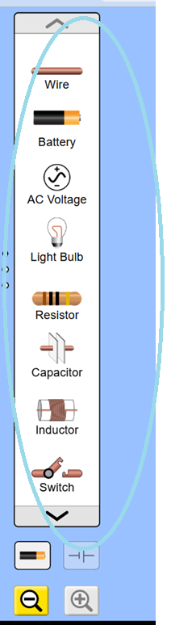

- Figure below is an example screenshot of the finished circuit:
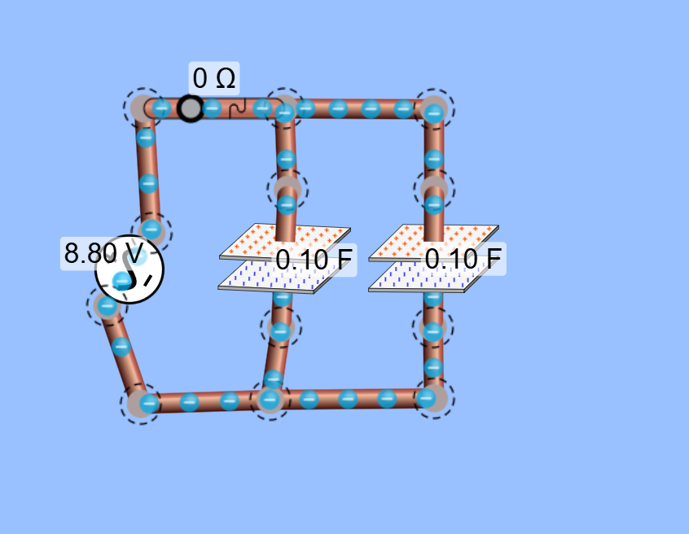

- You closed the switch of your circuit connection so that electrons will flow, and you see the storing of charges in the capacitor plates. Describe the flow of the electrons inside the wire.
- Connect the voltmeter and ammeter to measure the voltage and current as shown in the figure and observed: (example connections)

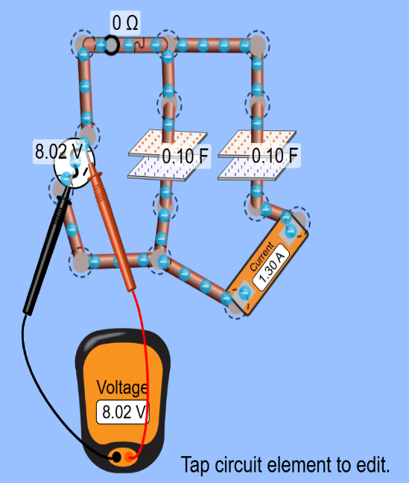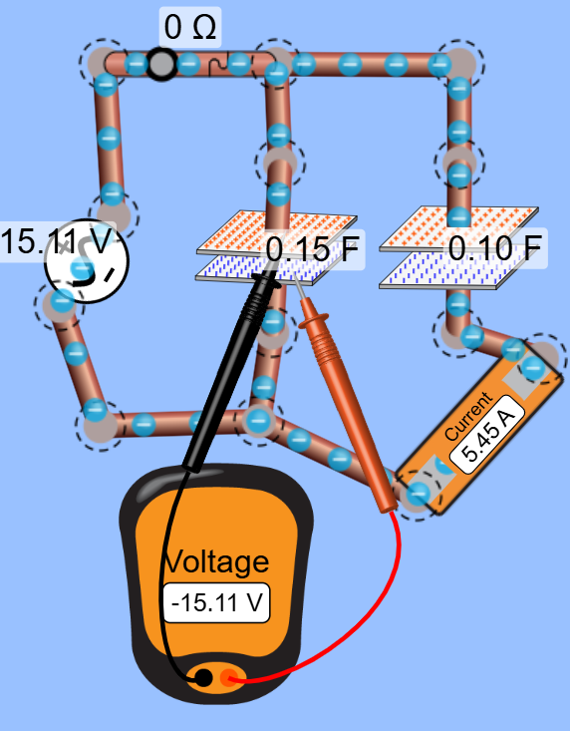
- Apply these connections to your series, parallel and combined connections.
- You can set your own voltage value just double click the voltage source:
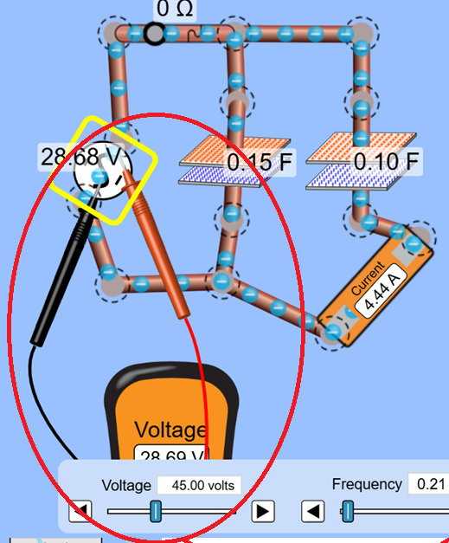
- Make sure that you have different values of the capacitors by clicking the capacitor and capacitance tab to change the values as shown below:
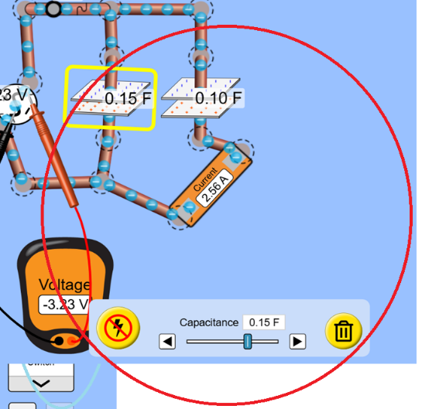
- Calculate the charges of each capacitor and the voltage across it.

DATA AND RESULTS

- i. For Series Connections (screenshots)

ii. Calculations for C_{T} and charges of each capacitor (series): Note: capacitors should have different values.

- i. For Parallel Connections (screenshots) which includes the voltage measurement to each capacitor.

ii. Calculations for C_{T} and charges of each capacitor (parallel): Note: capacitors should have different values.

- i. Combined Connections (screenshots) which includes the voltage measurement to each capacitor.

ii. Calculations for C_{T}, charges Q and the voltage across the capacitor (parallel): Note: capacitors should have different values.

Questions:
- Since you use the AC source for voltage, describe the flow of the electrons along the wire when the circuit is closed. What’s the difference to DC flow?

- What are your observations on the density of charges stored in the capacitors by comparing them through their proportionality?

- Are the voltage values across the capacitors consistent with their proportions when connected in series or parallel, based on your constructed circuit and the readings from your voltmeter tab?

Conclusion:

